**Basic Electrical Science Lab  
Course Code: EE152**

**Laboratory Manual**

Name: Sadat Zubin Aftab Shah

Roll No: 20CSE1030

Section: B

Academic Session: April – August 2021

**National Institute of Technology Goa**



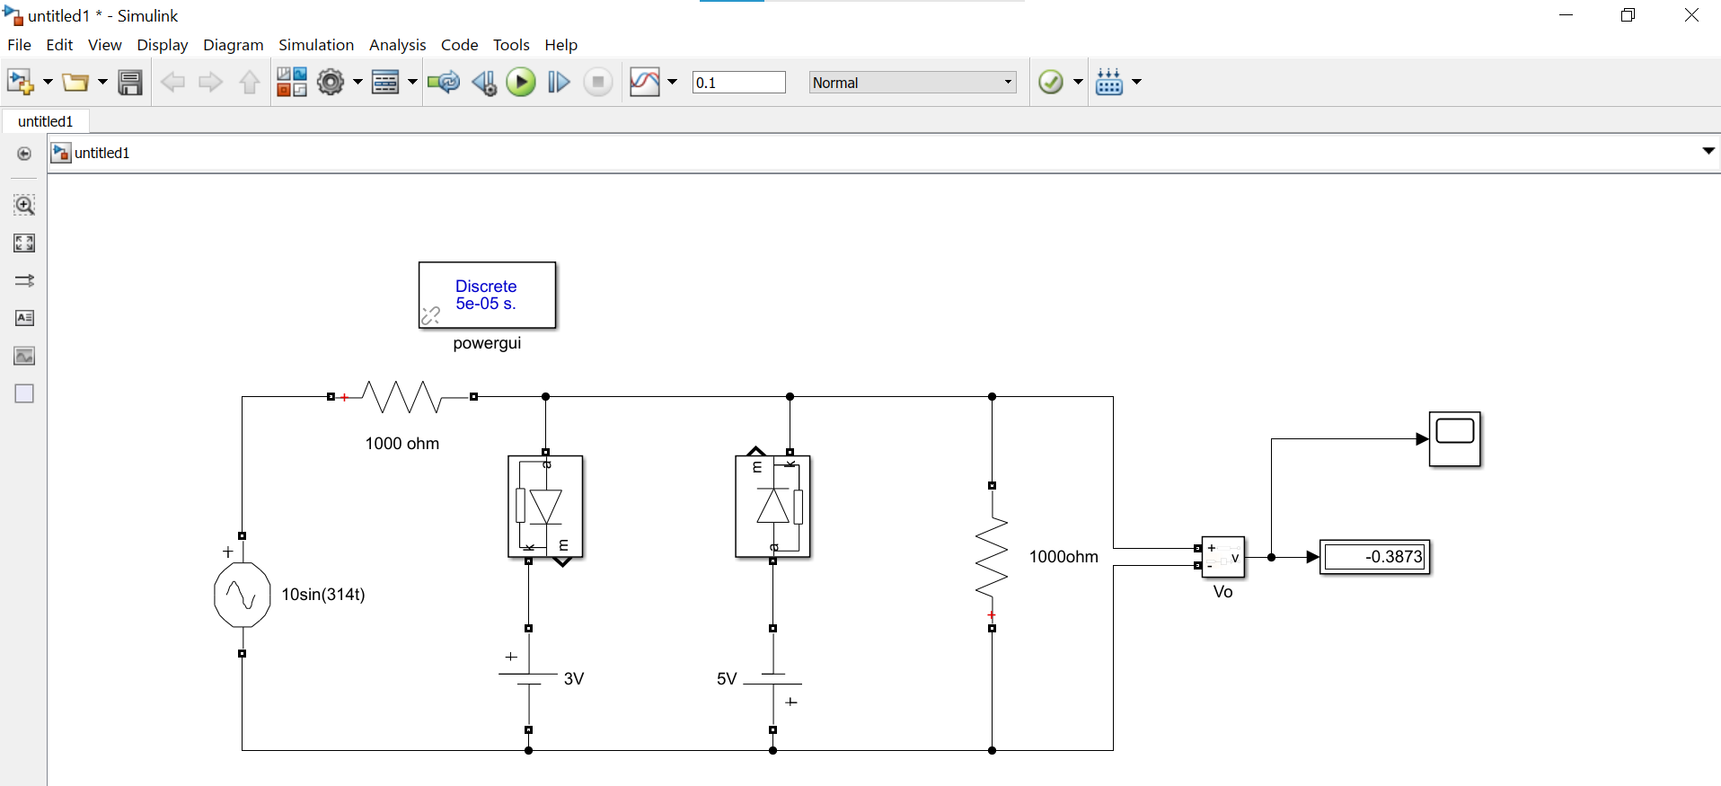

Circuit connections in Simulink

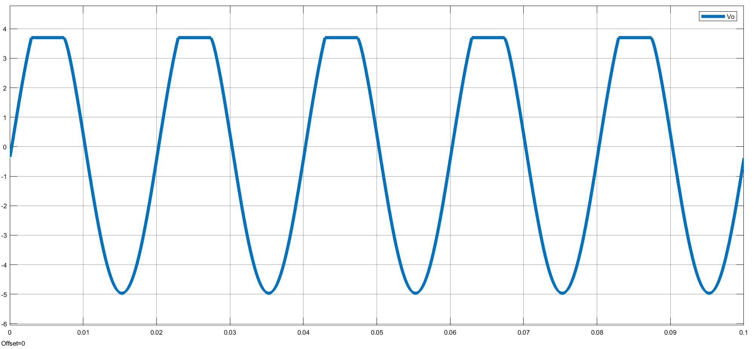

Output Voltage waveform Vo